**Flipkart Clone - Front Page**

***Overview***

This project is a **static and responsive front-end clone** of the Flipkart homepage, developed using **HTML, CSS, and Bootstrap**. It replicates the layout and user interface of Flipkart’s real website, including the navigation bar, banner slider, product section, and footer. This project was created to strengthen front-end development skills and demonstrate UI/UX design practices.

***Features***

* Fully responsive design using Bootstrap
* Navigation bar with logo, search bar, login, and cart section
* Carousel banner for promotional offers
* Product category cards in a grid layout
* Clean, modern, and user-friendly interface
* Footer with useful links and details
* Mobile and tablet responsive compatibility

***Technologies used***

* **HTML5** – Structure and layout
* **CSS3** – Custom styling and formatting
* **Bootstrap 5** – Responsive grid, layout, and UI components

***Screenshots***

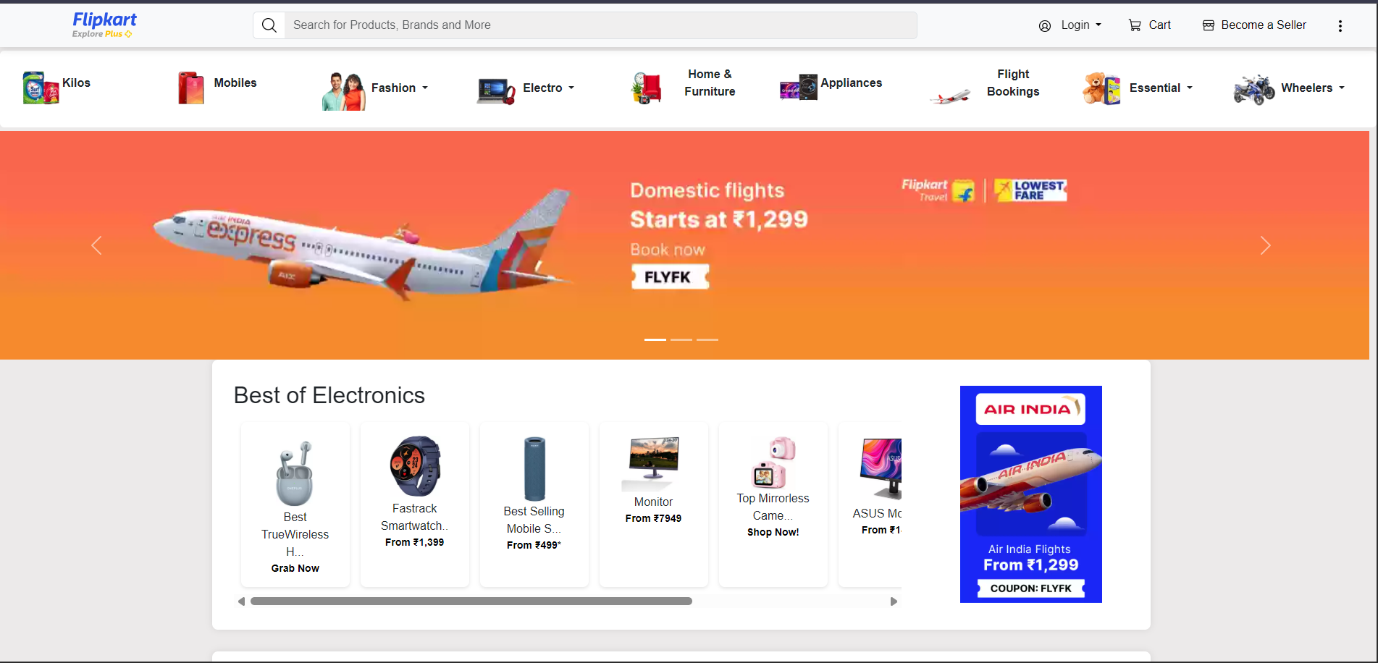

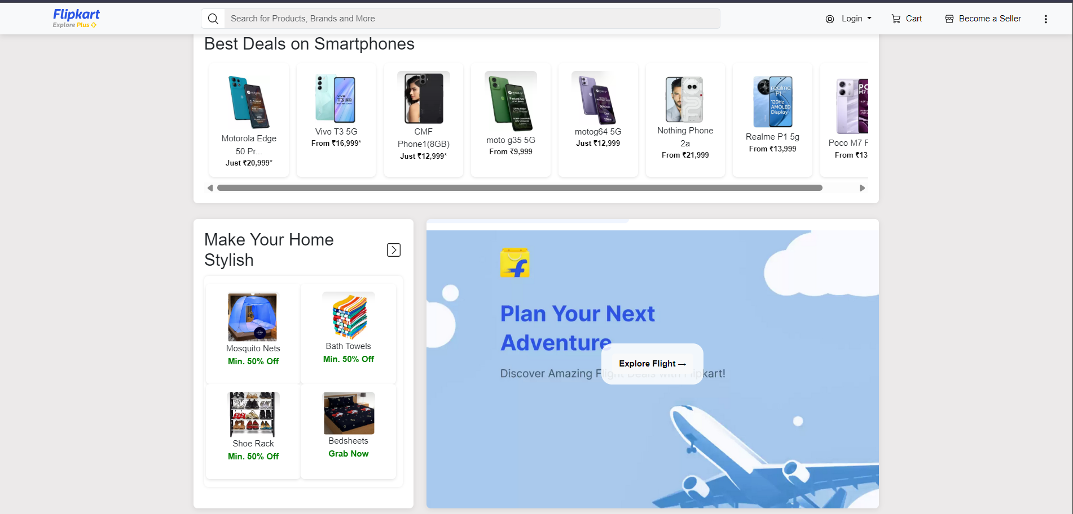

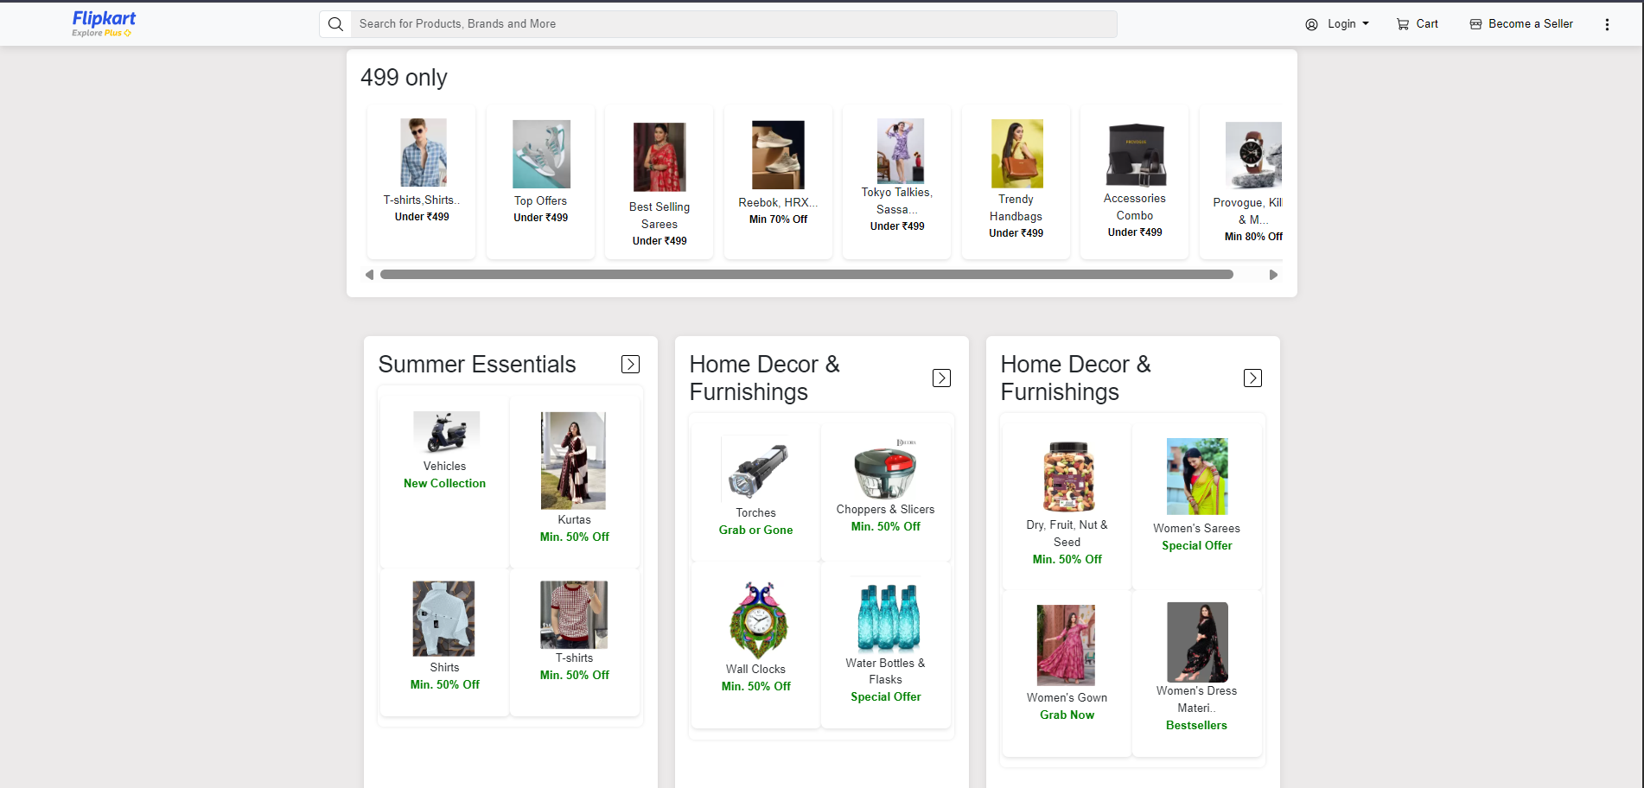

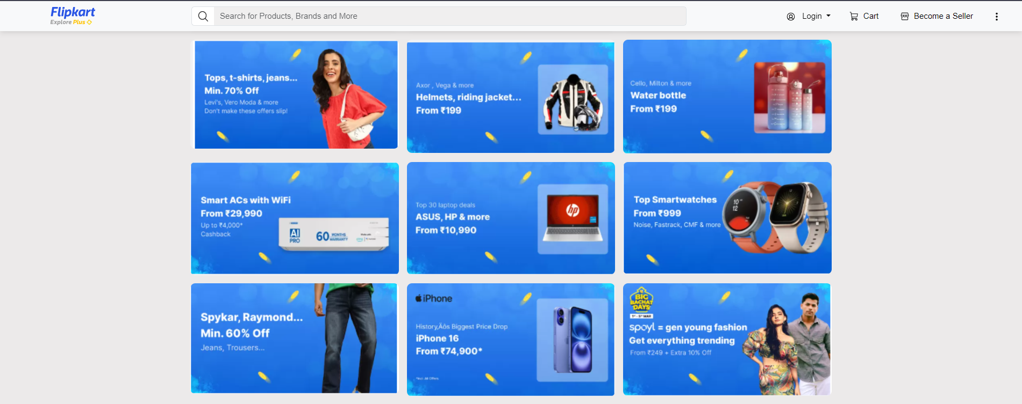

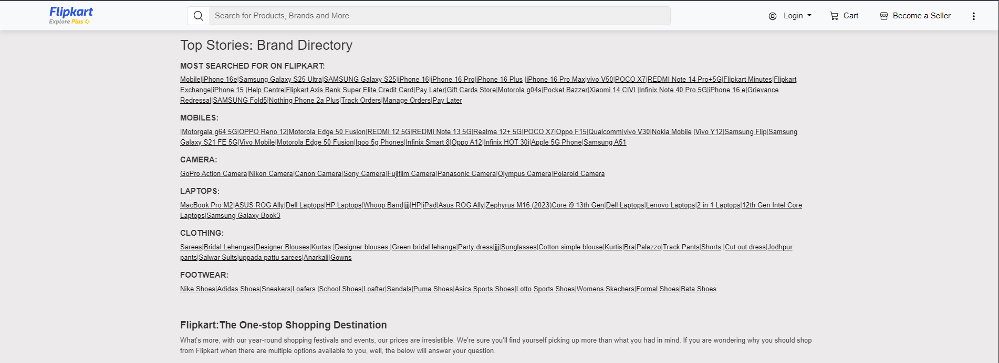

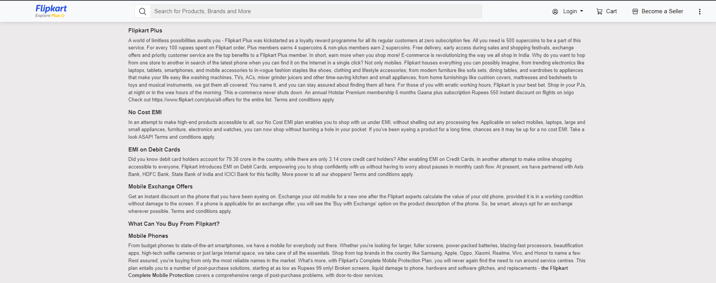

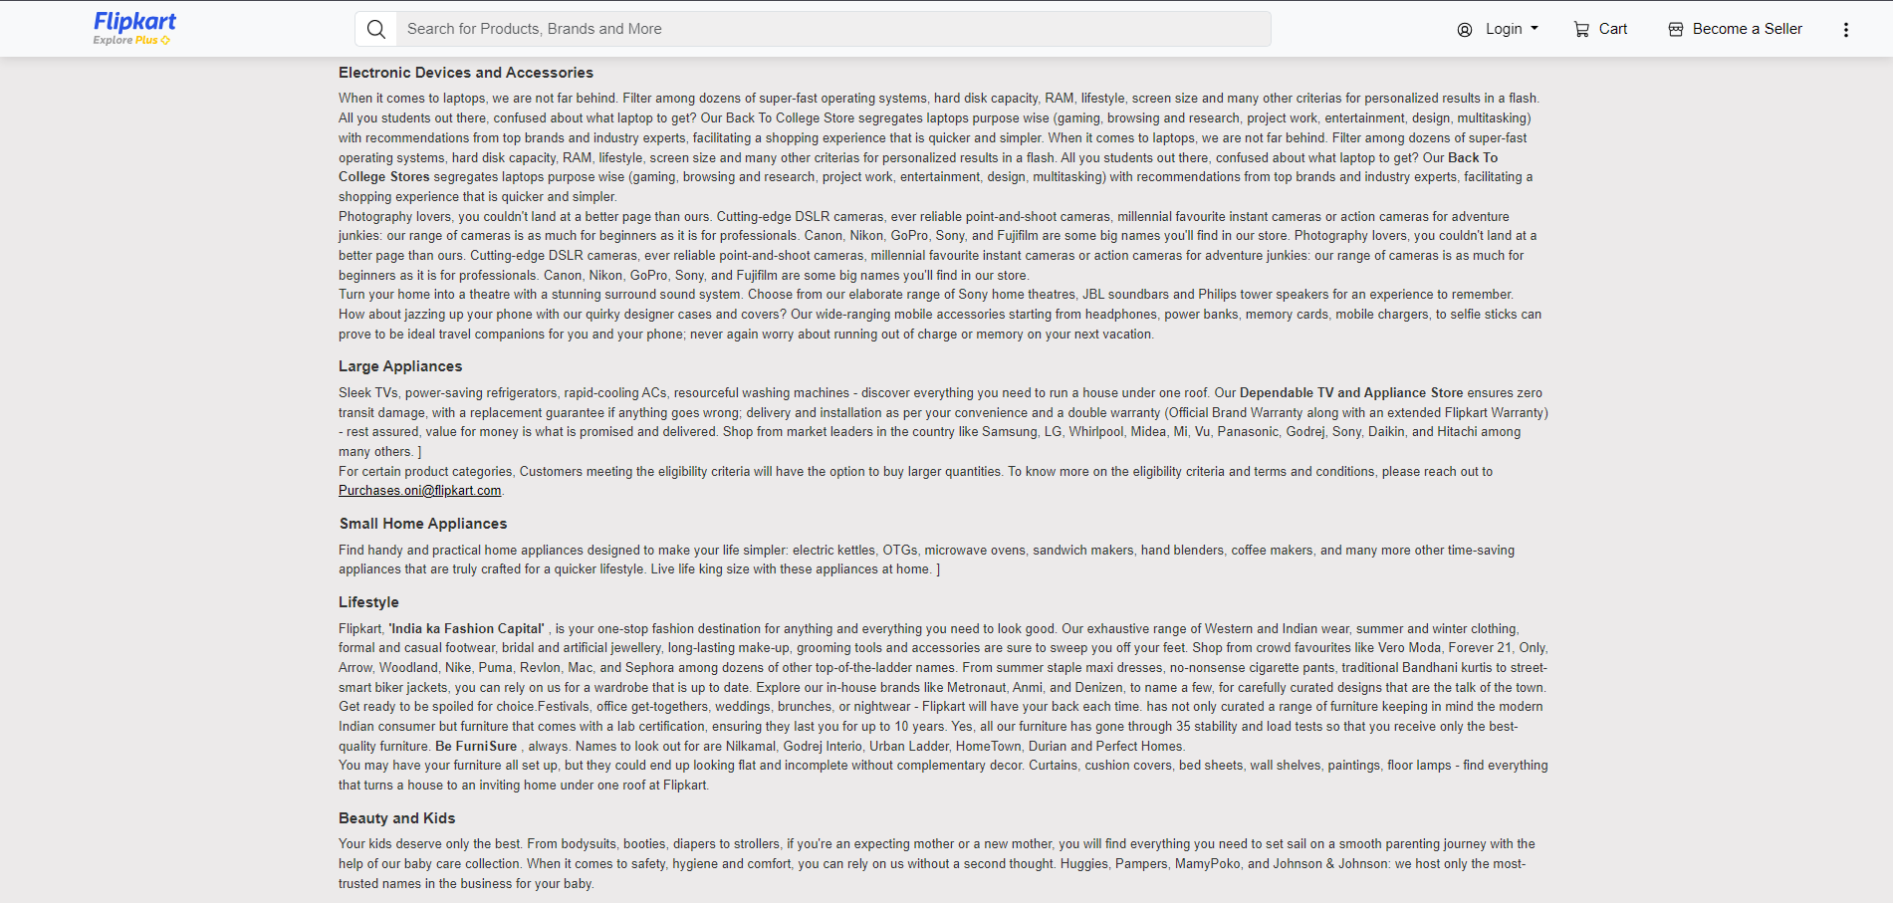

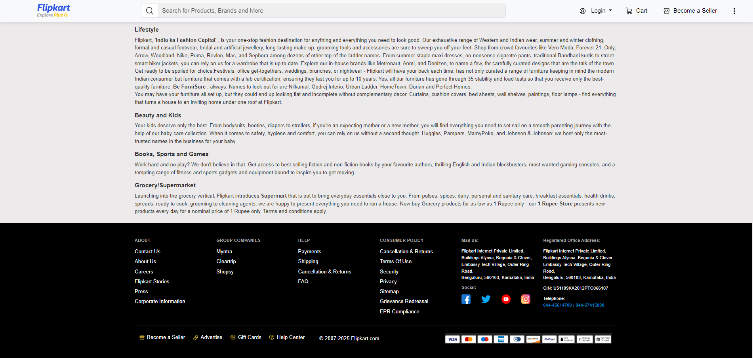

***Installation / How to Run the Project***

1. Download the project files or clone the GitHub repository
2. Locate the file named *index.html*
3. Open it in any modern browser (Chrome, Firefox, Edge, etc.)
4. No server or internet connection required

***Folder Structure***

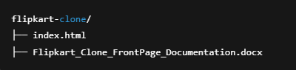

***Challenges Faced & Solutions***

**Challenge 1:** Matching Flipkart’s layout and proportions  
**Solution:** Used Bootstrap grid system and CSS Flexbox for precision

**Challenge 2:** Ensuring responsiveness on all devices  
**Solution:** Leveraged Bootstrap's media breakpoints and classes

**Challenge 3:** Creating a working carousel banner  
**Solution:** Integrated Bootstrap Carousel component with images

**Challenge 4:** Styling components to match Flipkart’s UI  
**Solution:** Applied custom CSS and Bootstrap overrides

***Learning Outcomes***

* Mastered the use of HTML & CSS for web layout
* Learned Bootstrap 5 for responsive and modern UI
* Understood how to replicate real-world websites
* Practiced page structuring and content alignment

***Author Info / Contact***

**Name:** Swathy Krishna  
📧 Email: swathykrishnamany01@gmail.com  
💻 GitHub: <https://github.com/SwathyKrishna02>

***License***

This project is licensed under the **MIT License**.  
You are free to use, modify, and share it for educational or personal use. Attribution is appreciated.